A REPORT OF ONE MONTH TRAINING
at
Digi Boulevards

SUBMITTED IN PARTIAL FULFILLMENT OF THE REQUIREMENT FOR THE
AWARD OF THE DEGREE OF

BACHELOR OF TECHNOLOGY
(Computer Science and Engineering)


JUNE-JULY, 2025

SUBMITTED BY :

NAME : SUNNY KUMAR
UNIVERSITY ROLL NO : 2302696
DEPARTMENT OF COMPUTER SCIENCE AND ENGINEERING

GURU NANAK DEV ENGINEERING COLLEGE LUDHIANA

(An Autonomous College Under UGC ACT)

CERTIFICATE

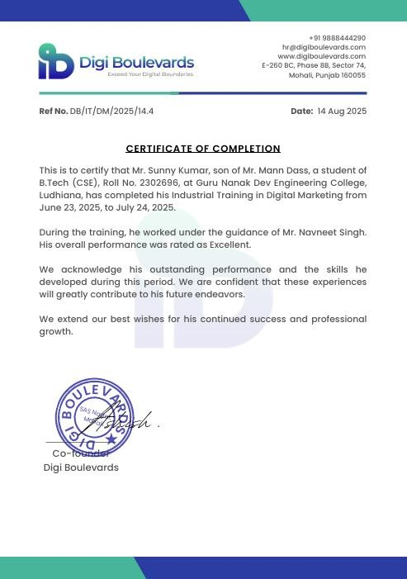

CANDIDATE’S DECLARATION

I, Sunny Kumar (Roll No. 2302696), student of B.Tech in Computer Science and Engineering at Guru Nanak Dev Engineering College, Ludhiana, hereby declare that the report entitled

“A REPORT ON ONE MONTH TRAINING AT DIGI BOULEVARDS”
is an authentic record of the work carried out by me during my one-month industrial training at Digi Boulevards, Mohali.
This report has been prepared by me as part of the partial fulfillment of the requirements for the award of the Bachelor of Technology (B.Tech) degree in Computer Science and Engineering under IK Gujral Punjab Technical University (IKGPTU).
I further declare that this report is based on my personal training experience and has not been submitted previously, in part or full, for the award of any degree or diploma to any other institution or university.

(Sunny Kumar)
Roll No.: 2302696
B.Tech (Computer Science & Engineering)
Guru Nanak Dev Engineering College, Ludhiana

ABSTRACT
Digital Marketing has become an inseparable component of modern business strategy due to rapid growth in internet penetration and digital platforms. This four week industrial training report documents the practical exposure gained at Digi Boulevards, Mohali, with emphasis on
Search Engine Optimization (SEO), Pay-Per-Click (PPC), Social Media Marketing (SMM), Content Marketing, Email Marketing, Web Analytics, and Technical SEO. The training combined theoretical concepts with real-world application through tools, case studies, and performance analysis. This report explains the fundamentals of digital marketing, training methodology, weekly learning outcomes, tools used, observations, results, and conclusions drawn during the training period.
The one-month training at Digi Boulevards focused on a comprehensive, data driven approach to Digital Marketing. The curriculum spanned foundational marketing principles, core digital channel management (SEO, Content, PPC, SMM), and advanced technical analysis. , keyword research for low competition, campaign setup in PPC environments, and leveraging social signals for brand authority.
The training culminated in a unique technical project, "Correlation Analysis of Technical Web
Reliability and Conversion Rate," which served as the cornerstone of the practical learning. This project utilized API integration (simulating PageSpeed Insights) and Python-based statistical modeling (Pandas, Regression) to quantitatively prove the direct business impact of technical website health (specifically Largest Contentful Paint - LCP and Server Response Time) on financial outcomes (Conversion Rate). The findings provided a measurable, databacked recommendation for prioritizing technical optimization, successfully bridging the gap between computer science and digital commerce strategy. This training significantly enhanced analytical, problem-solving, and implementation skills across the digital marketing ecosystem.

ACKNOWLEDGMENT

I would like to express my sincere and heartfelt gratitude to Digi Boulevards, Mohali, for providing me with the valuable opportunity to undergo four week industrial training in the field of Digital Marketing and Technical SEO. This training has played a significant role in enhancing my practical knowledge and understanding of real-world industry practices.
I am extremely thankful to my training mentor and the entire professional team at Digi Boulevards for their constant guidance, motivation, and technical support throughout the training period. Their systematic approach, practical demonstrations, and willingness to clarify doubts helped me gain in-depth knowledge of SEO, PPC advertising, social media marketing, content marketing, and web analytics. The friendly and professional environment at the organization made the learning process both effective and enjoyable.
I would also like to express my deep sense of gratitude to the Head of the Department, Department of Computer Science and Engineering, Guru Nanak Dev Engineering College, Ludhiana, for granting me permission to undertake this industrial training. I am sincerely thankful to all the faculty members of the department for their academic guidance, encouragement, and continuous support, which laid a strong foundation for understanding the technical concepts applied during the training.
(Sunny Kumar)
Roll No.: 2302696
B.Tech (Computer Science & Engineering)
Guru Nanak Dev Engineering College, Ludhiana.

ABOUT THE COMPANY / INSTITUTE
Digi Boulevards is a prominent consulting, services, and training firm specializing in cuttingedge Digital Marketing and Technical Solutions. Established with a vision to bridge the growing gap between theoretical knowledge and practical industry demands, the institution operates out of the thriving IT and education hub of Mohali, Punjab.
Detail Name Co-Founder Address Email Information Digi Boulevards Ashish Kumar E-260 BC, Phase 8B, Sector 74, Mohali, Punjab 160055 hr@digiboulevards.com.
Core Philosophy and Service Offerings Digi Boulevards operates on the core philosophy that modern digital strategy must be technology-centric and data driven. The company provides a comprehensive suite of digital services to clients across various sectors, including e-commerce, education, and finance. These services include advanced Search Engine Optimization (SEO), sophisticated Pay Per-Click (PPC) campaign management, robust social media strategies, and bespoke marketing automation solutions. This client-facing expertise forms the foundation of its training division. The institution prides itself on employing industry experts who utilize current best practices, algorithms, and technical stacks (including Python for analytics and various commercial platforms for implementation) to deliver measurable results for their
clients.
Key training domains include: Search Engine Optimization (SEO), Pay-Per-Click (PPC) Advertising, Social Media Marketing (SMM), Email Marketing, and specialized Marketing Data Analysis. This approach ensures that students leave with a portfolio of demonstrable skills, ready to contribute effectively in roles demanding both marketing acumen and analytical rigor. The commitment to technical excellence and professional mentorship distinguishes Digi
Boulevards as a vital hub for industrial training in the North Indian region.

LIST OF FIGURES

Figure No. | Title | Page No.
Figure 1.1 | Introduction to digital marketing | 9
Figure 1.2 | Evolution of Digital Marketing | 12
Figure 1.3 | Digital marketing Components | 14
Figure 1.4 | Objective of Digital marketing | 16
Figure 2.1 | Serarch Engine Optimization (SEO) | 19
Figure 2. 2 | Pay Per Click Process | 26
Figure 2. 3 | Website Analytics Works | 28
Figure 3.1 | Digital Marketing Skills | 29
Figure 3.2 | Industry Tool | 30
 |  | 32
Figure 3.3 | Digital Experience

TABLE OF CONTENTS

Chapter No. | Title | Page No.
CHAPTER 1 | INTRODUCTION | 1
1.1 | Introduction to Digital Marketing | 1
1.2 | The Shift from Traditional to Digital | 3
1.3 | Essential Characteristics of a Digital Presence | 5
1.4 | Evolution of Digital Marketing | 7
1.5 | Digital Marketing vs Traditional Marketing | 9
1.6 | Importance of Digital Marketing | 11
1.7 | Components of Digital Marketing | 13
1.8 | Role of Digital Marketing in the IT and Engineering Domain | 15
CHAPTER 2 | TRAINING WORK UNDERTAKEN | 18
2.1 | Overview | 18
2.2 | Training Methodology | 20
2.3 | Fundamentals of Digital Marketing | 21
2.4 | Search Engine Optimization (SEO) | 23

2.5 | Pay Per Click (PPC), Social Media and Email Marketing | 24
2.6 | Web Analytics and Reporting | 26
2.7 | Tools and Technologies Used | 29
CHAPTER 3 | RESULTS AND DISCUSSION | 30
3.1 | Technical Knowledge and Skills Acquired | 30
3.2 | Analytical and Data Interpretation Skills | 31
3.3 | Practical Exposure to Industry Tools | 31
3.4 | Professional and Soft Skills Development | 32
3.5 | Observations During the Training | 32
3.6 | Industry Exposure and Learning Outcomes | 33
3.7 | Overall Results of Training | 33
CHAPTER 4 | CONCLUSION AND FUTURE SCOPE | 34
4.1 | Conclusion | 34
4.2 | Future Scope | 35
4.3 | Final Remarks | 36
 | REFERENCES | 37
 | THANK YOU | 38

CHAPTER 1 – INTRODUCTION

1.1 Introduction to Digital Marketing
Digital Marketing (DM) is the promotion of products and services using digital media or electronic channels. It represents a paradigm shift from traditional, one way communication to an interactive, data-centric relationship between businesses and consumers. Unlike traditional methods (TV, print, radio) which are difficult to measure and often not cost-effective, DM provides unparalleled precision in targeting, measurement, and optimization.

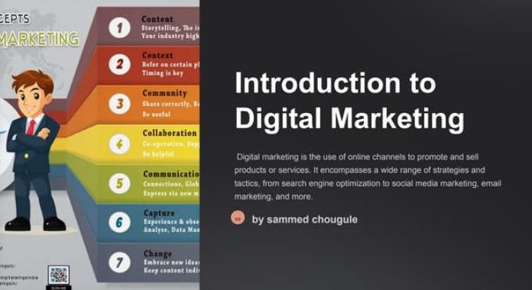
Figure 1.1: Introduction to digital marketing

1.2 The Shift from Traditional to Digital
The dominance of Digital Marketing is attributed to several key, measurable advantages:
- Communication is Bidirectional: DM facilitates two-way dialogue, allowing customers to interact, ask queries, and provide suggestions, thereby building greater brand loyalty and trust. • Global Reach: Digital channels instantly provide access to international markets, transcending geographical limitations in a highly cost-effective manner.
- Measurability and ROI: The most critical advantage. Analytics tools allow for precise tracking of every user interaction, making it simple to calculate the exact Return on Investment (ROI) for every dollar spent.
- Flexibility (Alteration): Digital advertisements and campaigns can be amended or paused in real-time even after being published, a capability impossible with traditional advertising.
- Speed for Brand Building: DM is significantly more efficient and faster for creating brand awareness and building an online reputation.

1.3 Essential Characteristics of a Digital Presence
To succeed in the digital environment, a business must secure and maintain several key digital assets:
- A Quality Company Website: This is the non-negotiable, 24/7 B2B or B2C portal. It must be technically robust, fast-loading, and mobile-friendly to serve as the central hub for all marketing campaigns.
- Social Media Presence: Active promotion on relevant social platforms (Facebook, X, LinkedIn) provides ease of communication across wide demographics and encourages global conversation about the brand.
- Blogging and Forums: Adhering to the axiom "Content is King," businesses must produce powerful, genuine, and compelling content. Regular engagement on relevant industry forums connects business themes to content and establishes authority.
- Business Listings: Registration on major listing services (Google Places, Bing, Yahoo! Local) ensures the business appears correctly on searches and maps, providing a foundational layer of local SEO.
The scope of digital marketing includes SEO, PPC advertising, social media marketing, content marketing, email marketing, affiliate marketing, influencer marketing, analytics, and marketing automation.
In the present era of rapid technological advancement, the internet and digital technologies have transformed almost every aspect of human life, including communication, education, business, and commerce. Traditional business practices have gradually shifted toward digital platforms due to increased internet accessibility, smartphone usage, and social media penetration. As a result, Digital Marketing has emerged as one of the most important tools for businesses to reach, engage, and retain customers in a competitive global market.
Digital marketing refers to the promotion of products, services, or brands using digital platforms such as search engines, websites, social media, email, and mobile applications. Unlike traditional marketing, digital marketing allows organizations to directly interact with customers, track their behavior, analyze performance, and optimize strategies in real time. Due to these advantages, digital marketing has become an essential component of modern business strategy.
Marketing is a systematic process of identifying customer needs, creating value-driven products or services, communicating those offerings effectively, and maintaining long-term customer relationships.
The ultimate goal of marketing is not only to sell products but also to satisfy customers and build brand loyalty.
In earlier times, marketing mainly depended on physical and offline methods such as newspapers, radio, television advertisements, posters, and banners. These methods were expensive, time-consuming, and limited in reach. Moreover, measuring the effectiveness of traditional marketing campaigns was difficult and often inaccurate. With the advancement of digital technology, businesses found a more efficient, interactive, and measurable approach, leading to the development of digital marketing.

1.4 Evolution of Digital Marketing
The evolution of digital marketing can be traced back to the early days of the internet. Initially, digital marketing consisted of basic email marketing and static website advertisements. As search engines developed, businesses began focusing on improving their visibility through search engine optimization (SEO).
The rise of social media platforms introduced a new dimension to digital marketing by enabling two-way communication between businesses and customers. Mobile technology further accelerated this growth by allowing users to access digital content anytime and anywhere. In recent years, analytics, automation, artificial intelligence, and machine learning have revolutionized digital marketing, making it more data-driven and personalized.
Today, digital marketing includes various techniques such as SEO, Pay Per Click (PPC) advertising, Social Media Marketing (SMM), Content Marketing, Email Marketing, Influencer Marketing, Affiliate Marketing, and Marketing Automation.
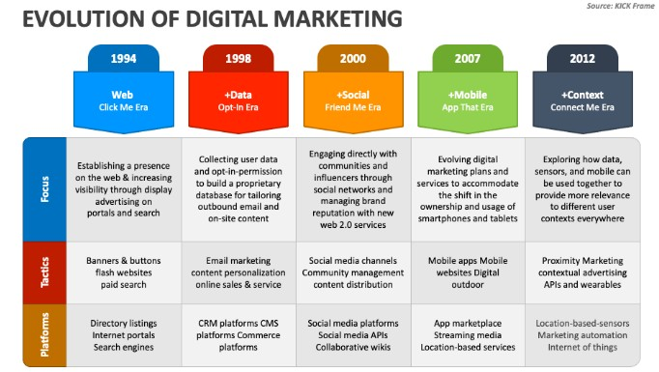
Figure 1.2: Evolution of Digital Marketing

1.5 Digital Marketing vs Traditional Marketing
Digital marketing differs significantly from traditional marketing in terms of approach, reach, cost, and effectiveness. Traditional marketing follows a one-way communication model where information is delivered to customers without interaction. It is often expensive and difficult to measure accurately.
In contrast, digital marketing is interactive, customer-centric, and measurable. It allows businesses to target specific audiences based on demographics, interests, and online behavior. Digital campaigns can be modified instantly based on performance analysis, making digital marketing more flexible and efficient than traditional marketing methods.

1.6 Importance of Digital Marketing
Digital marketing plays a crucial role in modern business growth due to several reasons. It provides global reach, enabling even small businesses to compete in international markets. It offers cost-effective marketing solutions with better return on investment (ROI). Digital marketing also allows real-time performance tracking, helping organizations make informed decisions.
Additionally, digital marketing enhances customer engagement by providing personalized content and interactive communication. In today’s competitive environment, having a strong digital presence is essential for brand recognition, customer trust, and long-term success.

1.7 Components of Digital Marketing
Digital marketing consists of several key components, each serving a specific purpose:
- Search Engine Optimization (SEO): Improves website visibility in organic search
results.
- Pay Per Click (PPC): Paid advertising model for instant traffic.
- Social Media Marketing (SMM): Promotes brands through social platforms.
- Content Marketing: Focuses on creating valuable and relevant content.
- Email Marketing: Used for communication and customer retention.
- Web Analytics: Measures performance and user behavior.
These components work together to form an integrated digital marketing strategy.
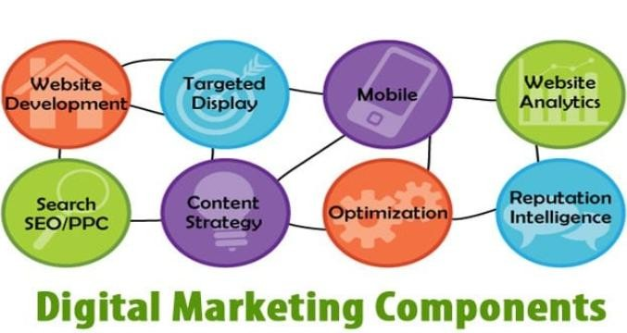
Figure 1.3: Digital marketing Components

1.8 Role of Digital Marketing in the IT and Engineering Domain
Digital marketing is closely related to information technology and computer science. Website development uses programming languages, databases, and server technologies. Search engines operate using algorithms, data structures, and artificial intelligence. Analytics tools process large datasets to generate insights.
For engineering students, digital marketing provides an opportunity to apply technical knowledge in real-world business scenarios. It demonstrates how technology and data are used to solve practical problems related to marketing and customer engagement.

1.9 Training Objectives and Scope

Scope of Digital Marketing
The scope of digital marketing is vast and continuously expanding due to technological innovation and increasing online activity. Digital marketing professionals are required in various industries such as e-commerce, education, healthcare, banking, tourism, and IT services.
Career opportunities in digital marketing include SEO specialist, digital marketing executive, PPC analyst, social media manager, content strategist, web analyst, and marketing automation expert. Due to high demand and continuous growth, digital marketing offers promising career prospects.

Objective
The primary goal of this industrial training at Digi Boulevards was to provide a comprehensive, 18-day exposure to the modern Digital Marketing landscape, with a strong emphasis on the technical and analytical requirements necessary for effective execution.
Export to Sheets The training successfully transitioned theoretical knowledge into a measurable, project-based skill set, equipping the trainee with the analytical foundation required for roles in data-driven marketing.
The training aimed to build a strong conceptual foundation of digital marketing, including its meaning, importance, scope, and difference from traditional marketing. This objective helped in understanding how digital is a platforms are used to promote products and services effectively.
This included keyword research, on-page SEO, off-page SEO, and technical SEO practices. The main objectives of the four week industrial training were to understand digital marketing fundamentals, gain hands-on experience with industry tools, analyze real-world marketing data, develop professional skills, and bridge the gap between academic learning and industry practices.
The major objectives of the digital marketing training were:
- To understand digital marketing concepts and terminology
- To learn SEO techniques and website optimization
- To understand paid advertising models such as PPC
- To gain knowledge of social media and content marketing
- To analyze website traffic using analytics tools

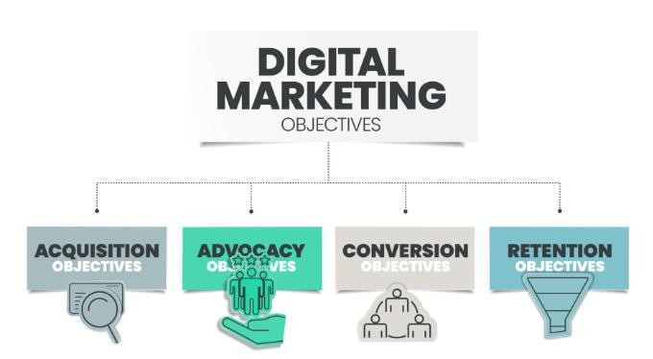
Figure 1.4: Objective of Digital marketing

CHAPTER 2 – TRAINING WORK UNDERTAKEN

2.1 Overview
This chapter describes the practical work, activities, and learning experiences undertaken during the four week industrial training at Digi Boulevards, Mohali. The training was structured in a systematic manner to provide both theoretical understanding and hands-on practical exposure to digital marketing and technical SEO concepts. The training focused on real-world applications, tools, and industry practices to bridge the gap between academic knowledge and professional requirements.

2.2 Training Methodology
The training followed a step-by-step and practical-oriented methodology, which included:
- Classroom-style theoretical session
- Live demonstrations using real tools
- Hands-on practice on digital platforms
- Case studies and examples
- Performance analysis and reporting
Each concept was first explained theoretically and then implemented practically to ensure clear understanding. This chapter describes the practical work, activities, and learning experiences undertaken during the four week industrial training at Digi Boulevards, Mohali. The training was structured in a systematic manner to provide both theoretical understanding and hands-on practical exposure to digital marketing and technical SEO concepts.

2.3 Week-wise Training Details

2.3.1 Week 1: Introduction and Fundamentals of Digital Marketing
The first week focused on understanding the basic concepts of digital marketing and its importance in today’s digital era. The following topics were covered:
- Overview of marketing and digital marketing
- Difference between traditional marketing and digital marketing
- Digital marketing channels (SEO, PPC, SMM, Email Marketing)
- Role of websites in digital marketing
- Introduction to content marketing
During this week, emphasis was placed on understanding how businesses use digital platforms to reach customers and measure performance.

2.3.2 Week 2: Search Engine Optimization (SEO)
The second week focused on Search Engine Optimization, which is one of the most important components of digital marketing. The following activities were performed:
- Understanding how search engines work (crawling, indexing, ranking)
- Keyword research techniques
- On-page SEO (title tags, meta descriptions, headings, content optimization)
- Off-page SEO (backlinks, social bookmarking, guest posting)
- Technical SEO (page speed, mobile friendliness, site structure)
Hands-on practice included analyzing websites, identifying SEO issues, and understanding how optimization improves search engine rankings.
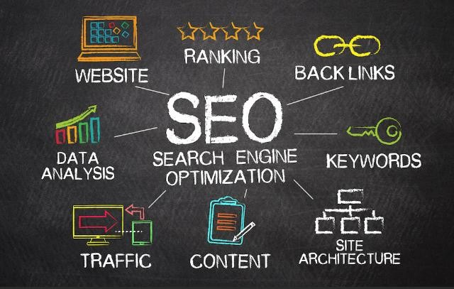
Figure 2.1: Serarch Engine Optimization (SEO)
Search Engine Optimization (SEO) is a core component of digital marketing that focuses on improving the visibility of a website in the organic results of search engines such as Google. SEO involves a set of techniques and practices that help search engines understand website content and rank it higher for relevant search queries. Higher rankings result in increased website traffic, better brand recognition, and improved business opportunities.
In today’s digital world, most users depend on search engines to find information, products, and services. Websites appearing on the first page of search engine result pages (SERPs) receive the majority of user attention, while websites on later pages receive very little traffic. Therefore, SEO plays a critical role in ensuring online success.

Importance of SEO in Digital Marketing
SEO is considered one of the most effective and sustainable digital marketing strategies. Unlike paid advertisements, SEO provides long-term benefits without continuous financial investment.
Some important advantages of SEO are:
- Increased organic website traffic
- Improved brand credibility and trust
- Cost-effective marketing approach
- Better user experience
- Long-term online visibility
SEO is especially beneficial for small and medium-sized businesses as it allows them to compete with larger organizations in the digital marketplace.

Working of Search Engines
To understand SEO, it is essential to understand how search engines work. Search engines perform their operations in four main steps:
Crawling
Crawling is the process by which search engine bots visit web pages and collect information.
These bots follow links to discover new and updated content.

Indexing
After crawling, search engines store collected information in a database called an index. During indexing, search engines analyze page content, keywords, images, and structure.

Ranking
Ranking is the process of arranging indexed pages based on relevance and quality. Search engines use algorithms that consider various factors such as content quality, keywords, backlinks, page speed, and user experience.

Displaying Results
When a user enters a search query, the search engine displays the most relevant and useful pages from its index on the search engine result page.
Types of Search Engine Optimization
SEO is mainly divided into three categories:

On-Page SEO
On-page SEO refers to optimization techniques applied directly on a website to improve its ranking and relevance.
Major on-page SEO elements include:
- High-quality and relevant content
- Proper keyword usage
- Title tags and meta descriptions
- Heading tags (H1, H2, H3)
- Image optimization using alt text
- Internal linking
- URL structure
Proper on-page SEO helps search engines understand the content and improves user experience.

Off-Page SEO
Off-page SEO refers to activities performed outside the website to improve its authority and trustworthiness.
Key off-page SEO techniques include:
- Backlink creation from authoritative websites
- Social media promotion
- Guest posting
- Brand mentions
- Directory submissions
High-quality backlinks play a significant role in improving search engine rankings.

Technical SEO
Technical SEO focuses on improving the technical structure of a website so that search engines can crawl and index it efficiently.
Important technical SEO aspects include:
- Website loading speed
- Mobile friendliness
- Secure HTTPS connection
- XML sitemap
- Robots.txt file
- Fixing crawl errors and broken links
Technical SEO improves both search engine performance and user experience.

Keyword Research in SEO
Keyword research is the foundation of SEO. It involves identifying words and phrases that users commonly search for. Effective keyword research considers:
- Search volume
- Competition level
- User intent
- Long-tail keywords
Long-tail keywords are more specific and usually result in higher conversion rates.

SEO Tools Used During Training
During the industrial training, various SEO tools were introduced to analyze and improve website performance. These tools help in keyword research, competitor analysis, SEO auditing, and performance monitoring. Using these tools improves accuracy and efficiency in SEO
activities.

Benefits of SEO
SEO offers several benefits to businesses, such as:
- Higher website visibility
- Increased organic traffic
- Improved customer trust
- Better conversion rates
- Sustainable online growth
SEO is a continuous process that requires regular monitoring and optimization.

Challenges in SEO
Despite its benefits, SEO also faces challenges such as:
- Frequent changes in search engine algorithms
- High competition for popular keywords
- Time required to achieve results
- Continuous need for content updates
However, with proper strategy and consistency, these challenges can be managed effectively.

2.3.3 Week 3: Pay Per Click (PPC), Social Media and Email Marketing
Pay Per Click (PPC) is an online advertising model in which advertisers pay a fee each time their advertisement is clicked by a user. PPC is a form of paid digital marketing that allows businesses to display advertisements on search engines, websites, and social media platforms. The most common PPC platform is Google Ads, where ads appear at the top of search engine result pages.
PPC is widely used because it provides instant visibility, unlike SEO which requires time to show results. Businesses use PPC to generate immediate traffic, leads, and sales.

Importance of PPC in Digital Marketing
PPC plays an important role in digital marketing due to the following reasons:
- Provides immediate traffic to websites
- Allows precise targeting of audience
- Delivers measurable and controllable results
- Supports brand awareness and lead generation
- Complements SEO strategies
PPC is especially useful for new websites and promotional campaigns where quick results are required.

Working of PPC Advertising
PPC works on a bidding system. Advertisers bid on keywords that users are likely to search for. When a user searches for a keyword, the search engine runs an auction to decide which ads will appear. The position of the ad depends on:
- Bid amount
- Quality Score
- Relevance of the ad and landing page
Advertisers are charged only when users click on their ads.

Google Ads Platform
Google Ads is the most popular PPC advertising platform. It allows advertisers to create different types of ads such as:
- Search Ads
- Display Ads
- Video Ads
- Shopping Ads
Google Ads provides advanced targeting options based on location, device, time, demographics, and user behavior.

In the third week, focus shifted to paid marketing and social media platforms. The training included:
- Introduction to Pay Per Click advertising
- Understanding Google Ads campaign structure
- Keyword bidding and Quality Score
- Social Media Marketing strategies
- Content planning for social media platforms
- Introduction to Email Marketing and campaign types
This week helped in understanding how paid promotions generate instant traffic and how social media helps in brand engagement.
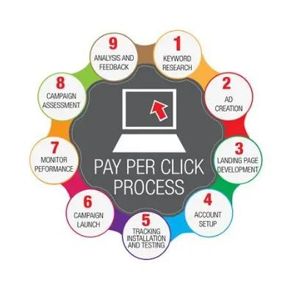
Figure 2.2:Pay Per Click Process

2.3.4 Week 4: Web Analytics and Reporting
The final week focused on analytics, performance measurement, and reporting. Topics covered included:
- Introduction to web analytics
- Understanding Google Analytics
- Traffic source analysis
- User behavior analysis
- Conversion tracking
- Report preparation and performance evaluation
This week helped in understanding how data is analyzed to make informed marketing decisions.

2.4 Tools and Technologies Used
During training, various industry-standard tools were introduced:
- Google Analytics
- Google Ads
- Keyword research tools
- SEO audit tools
- Social media platforms
- Keyword research tools
These tools helped in understanding real-world digital marketing workflows
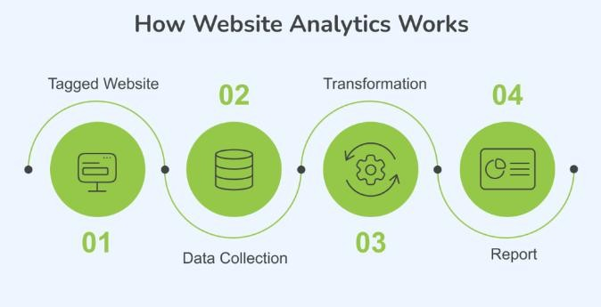
Figure 2.3:Website Analytics Works

2.5 Learning Experience
The training provided a clear understanding of how digital marketing strategies are planned, executed, monitored, and optimized in real industry environments. The practical exposure improved technical, analytical, and problem-solving skills.
The training provided a clear understanding of how digital marketing strategies are planned, executed, monitored, and optimized in real industry environments.
Social Media Marketing (SMM) involves the use of social networking platforms to promote products, services, and brands.It focuses on engaging users, building relationships, and creating brand awareness. Social media has become an essential part of digital marketing due to its wide reach and interactive nature. The practical exposure improved technical, analytical, and problem-solving skills.
The training provided a clear understanding of how digital marketing strategies are planned, executed, monitored, and optimized in real industry environments

CHAPTER 3 – RESULTS AND DISCUSSION

3.1 Overview
This chapter discusses the outcomes achieved during the four week industrial training at Digi Boulevards, Mohali. It explains the skills acquired, practical exposure gained, observations made during training, and how the theoretical concepts learned in academics were applied in real industry scenarios. The chapter also highlights the impact of digital marketing techniques on business growth and decision making.

3.2 Technical Knowledge and Skills Acquired
During the training period, significant technical knowledge related to digital marketing and technical SEO was gained. The trainee developed a clear understanding of how websites are optimized to improve their visibility on search engines. Concepts such as keyword research, onpage SEO, off-page SEO, and technical SEO were practically observed and understood.
In addition, hands-on exposure to Pay Per Click (PPC) advertising helped in understanding how paid campaigns are created, monitored, and optimized. The training also improved knowledge of social media marketing, content planning, email marketing, and analytics. These skills are essential for modern digital marketing roles and are highly relevant in the IT industry.

3.3 Analytical and Data Interpretation Skills
One of the major outcomes of the training was the development of analytical skills. The trainee learned how to analyze website traffic, user behavior, and conversion data using analytics tools. Understanding metrics such as traffic sources, bounce rate, session duration, and conversion rate helped in evaluating the effectiveness of marketing strategies.The ability to interpret reports and draw meaningful conclusions from data enhanced decision-making skills.
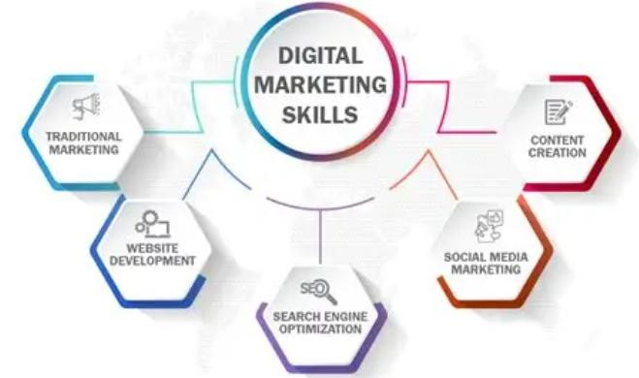
Figure 3.1: Digital Marketing Skills

3.4 Practical Exposure to Industry Tools
The training provided exposure to various industry-standard tools used in digital marketing. Practical sessions helped in understanding how these tools are used to monitor performance, identify issues, and improve results. Observing live dashboards and reports provided clarity on how organizations track marketing success and optimize campaigns regularly.
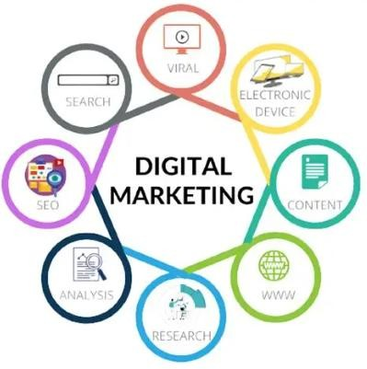
Figure 3.2: Industry Tool

3.5 Professional and Soft Skills Development
Apart from technical skills, the training significantly improved professional and soft skills. Regular interaction with trainers and team members improved communication skills. Working under deadlines enhanced time management and discipline. Team-based learning activities encouraged collaboration and professional behavior.
The training also instilled a sense of responsibility and work ethics, which are essential qualities in a professional environment.

3.6 Observations During the Training
Several important observations were made during the training period:
- Digital marketing strategies are highly dependent on data and performance metrics.
- Search Engine Optimization provides long-term benefits compared to paid advertising.
- Quality content plays a crucial role in user engagement and retention.
- Website performance and technical structure directly affect user experience.
- Analytics is essential for measuring success and improving strategies.
These observations helped in understanding the real impact of digital marketing on business growth.

3.7 Industry Exposure and Learning Outcomes
The training offered real industry exposure by demonstrating how digital marketing projects are planned, executed, and evaluated. It helped in understanding organizational structure, professional communication, and client-oriented approaches. The learning outcomes included improved confidence, enhanced technical skills, and readiness for future industry challenges.
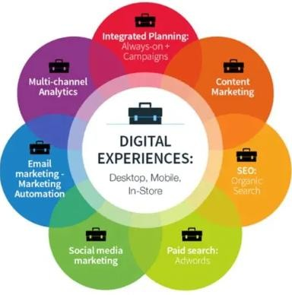
Figure 3.3: Digital Experience

3.8 Overall Results of Training
Overall, the training was successful and productive. It fulfilled academic objectives, improved practical knowledge, and provided a clear understanding of industry expectations. The experience gained during training will be beneficial for academic projects, internships, and future employment. The overall results of the training can be evaluated in terms of technical knowledge gained, skill development, professional growth, and industry readiness.
One of the most significant outcomes of the training was the development of a strong understanding of digital marketing fundamentals.
The trainee gained clarity on how various digital marketing channels such as Search Engine
Optimization (SEO), Pay Per Click (PPC) advertising, Social Media Marketing, Content Marketing, Email Marketing, and Web Analytics work together to form an integrated marketing strategy. This holistic understanding helped in recognizing the importance of coordination between different digital platforms.

CHAPTER 4 – CONCLUSION AND FUTURE SCOPE

4.1 Conclusion
The four week industrial training in Digital Marketing at Digi Boulevards, Mohali, was a valuable and informative learning experience that provided practical exposure to modern digital marketing practices. The training helped in understanding the fundamentals and importance of digital marketing in today’s technology-driven business environment. Through systematic training sessions, the trainee gained knowledge of various digital marketing domains such as
Search Engine Optimization (SEO), Pay Per Click (PPC) advertising, Social Media Marketing, Content Marketing, Email Marketing, and Web Analytics.
The training significantly enhanced technical, analytical, and professional skills. Practical exposure to SEO and PPC helped in understanding how websites and paid campaigns are optimized for better visibility and performance. Social media and email marketing sessions improved skills related to content planning.The use of analytics tools emphasized the importance of data-driven decision making and performance evaluation in digital marketing strategies.From an academic perspective, the training complemented the engineering curriculum by demonstrating real-world applications of computer science concepts such as data analysis, website performance, and automation.
Overall, the industrial training successfully bridged the gap between theoretical learning and real-world industry practices. It improved professional confidence, communication skills, teamwork, and understanding of organizational work culture. The knowledge and experience gained during this training will be highly beneficial for future academic projects and career opportunities in digital marketing, analytics, and information technology fields.

4.2 Future Scope
Digital marketing has a broad and promising future due to rapid technological advancements and the increasing shift of businesses toward online platforms. As organizations continue to focus on digital presence, the demand for skilled digital marketing professionals is expected to grow significantly. The knowledge and practical exposure gained during this industrial training provide a strong foundation for further learning and specialization in this field.
Digital marketing is a fast-growing field with continuous advancements in technology and online platforms. The knowledge gained during this industrial training provides a strong base for further learning and professional development.
In the future, advanced areas such as SEO analytics, social media strategy, paid advertising optimization, marketing automation, and data-driven decision making will play a crucial role in digital marketing success. Continuous learning and skill enhancement can open career opportunities in roles such as digital marketing executive, SEO specialist, PPC analyst, social media manager, and digital marketing consultant. Overall, digital marketing offers long-term career growth and wide employment opportunities across various industries.
The skills acquired lay a solid foundation for advanced specialization in high demand areas:
- Predictive Marketing Analytics: Moving beyond correlation to building predictive models for customer churn, lifetime value (CLV), and budget allocation using advanced machine learning techniques.
- Technical SEO Specialization: Deepening expertise in Core Web Vitals, advanced serverside rendering (SSR), and JavaScript SEO implementation to solve complex indexing
challenges.

- Machine Learning in Advertising: Exploring how AI/ML models are used for real-time bidding, dynamic creative optimization, and sophisticated audience segmentation within ad platforms. Potential career paths include Digital Marketing Strategist, Technical SEO Specialist, PPC Professional, and Marketing Data Analyst, all of which demand the hybrid skill set developed during this training.

4.3 Final Remarks
This training program has not only strengthened technical knowledge in digital marketing but also contributed significantly to personal growth and professional development. Through a structured and hands-on learning environment, the training enhanced analytical thinking, strategic planning ability, and a data-driven mindset essential for modern digital marketing practices.
To sustain and build upon the learning gained during this training, learners are encouraged to explore advanced courses, professional certifications, and continuous practice using industry tools related to SEO, PPC, social media analytics, and marketing automation. Actively working on real-world projects and live campaigns will further improve practical understanding and confidence.
Finally, learners are motivated to experiment with advanced digital marketing strategies, analyze larger datasets, test new advertising approaches, and explore emerging technologies such as automation and AI-driven marketing. With consistent effort, curiosity, and continuous learning, the knowledge and experience gained through this training can pave the way for a successful and impactful career in the field of Digital Marketing and online business strategy.

REFERENCES
- Philip Kotler, Kevin Lane Keller, Marketing Management, 15th Edition, Pearson Education, New Delhi, 2016.
- Dave Chaffey and Fiona Ellis-Chadwick, Digital Marketing: Strategy, Implementation and Practice, 7th Edition, Pearson Education, London, 2019.
- Ryan Deiss and Russ Henneberry, Digital Marketing for Dummies, Wiley Publishing, Hoboken, New Jersey, 2020.
- Eric Enge, Stephan Spencer, Jessie Stricchiola, and Rand Fishkin, The Art of SEO, 3rd Edition, O’Reilly Media, Sebastopol, CA, 2015.
- Adam Clarke, SEO 2023: Learn Search Engine Optimization, Independently Published, 2023.
- Google, Search Engine Optimization (SEO) Starter Guide, Google Developers
Documentation,2024.
Available: https://developers.google.com/search/docs
- Google Analytics Team, Google Analytics Documentation, 2024.
Available: https://developers.google.com/analytics
- Neil Patel, Advanced Digital Marketing Strategies, Neil Patel Digital, 2023.
Available: https://neilpatel.com
- HubSpot Academy, Digital Marketing Certification Course, HubSpot, 2024.
Available: https://academy.hubspot.com

THANK YOU
I would like to express my sincere gratitude to everyone who supported me during the completion of this one-month industrial training and the preparation of this report.
A special thanks to Digi Boulevards, Mohali, for providing a practical platform to learn and apply Machine Learning concepts.
I am also thankful to Guru Nanak Dev Engineering College, Ludhiana, my project guide, faculty members, and peers for their guidance, encouragement, and continuous support.
This experience has been invaluable in enhancing my knowledge, skills, and confidence in the field of Digital Marketing.

Sunny Kumar
Roll No.: 23026965
B.Tech (Computer Science & Engineering)
Guru Nanak Dev Engineering College, Ludhiana

